**Vibrations:**

**About Our Sensor:**

The sensor that is currently being used in the facility has 3 components with each having 3 separate dimensional values.

This is a 9-axis sensor: 3-dimensional gyroscope, 3-dimensional magnetometer, and 3-dimensional accelerometer.

To be successful at least we would need data per second.

**Metrics:**

1. 3-Dimensional Gyroscope:

Gyroscopes measure the rate of rotation around each axis. The raw data might include angular velocity values in degrees per second (dps) or radians per second (rad/s) for each of the three axes (X, Y, and Z).

Gyro_X: 10.5 dps

Gyro_Y: -3.2 dps

Gyro_Z: 7.0 dps

1. 3-Dimensional Magnetometer:

Magnetometers measure the strength and direction of the magnetic field along each axis. The raw data could include magnetic field strength values in microteslas (µT) or Gauss for each of the three axes.

Mag_X: -20.1 µT

Mag_Y: 15.8 µT

Mag_Z: -5.2 µT

1. 3-Dimensional Accelerometer:

Accelerometers measure acceleration, including the force of gravity, along each axis. The raw data might include acceleration values in meters per second squared (m/s²) for each of the three axes.

Acc_X: 9.81 m/s² (if sensor is positioned correctly this should represent gravity)

Acc_Y: 0.1 m/s²

Acc_Z: -0.2 m/s²

**Calculations:**

1. Orientation and Rotation:

Quaternion Calculation: Convert gyroscope data to quaternion representation for accurate orientation tracking. Quaternion-based sensor fusion algorithms, such as Madgwick or Mahony filters, can be used for this purpose.

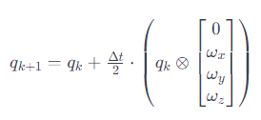

1. Motion Analysis:

Integration of Accelerometer Data: Integrate accelerometer data twice (once for each axis) to estimate velocity and displacement. Be aware of the drift over time due to noise and bias errors.

Velocity and Displacement: If high accuracy is required, consider using sensor fusion algorithms that take into account both accelerometer and gyroscope data.

1. Threshold Detection:

Threshold Detection: Set thresholds for acceleration or gyroscope values to trigger specific actions or events based on user-defined criteria.

1. Magnetic Heading:

Compass Heading: Combine magnetometer data with accelerometer data to calculate a tilt-compensated compass heading. This helps in determining the device's orientation relative to the Earth's magnetic field.

1. Sensor Calibration:

Calibration: Implement calibration routines to compensate for sensor biases, scale factors, and misalignments. Calibration is crucial for obtaining accurate and reliable measurements.

1. Filtering:

Low-Pass Filtering: Apply low-pass filters to gyroscope and accelerometer data to reduce high-frequency noise. This is important for obtaining smooth and stable measurements.

High-Pass Filtering: Use high-pass filters to remove slow changes in sensor data. This is useful for isolating short-term, dynamic motions.

1. *Energy Expenditure Estimation:*

*Calculate Energy Expenditure: If working with accelerometry data for a device, you can estimate energy expenditure based on movement patterns.*

1. *Gesture Recognition:*

*Gesture Recognition: Analyze accelerometer and gyroscope data patterns to recognize specific gestures or movements. This is useful in applications such as gesture-controlled devices.*

1. *Temperature Compensation:*

*Temperature Compensation: Account for temperature variations by applying appropriate compensation to sensor readings. Read that the MPU9250 may provide temperature data*

**Frequency:**

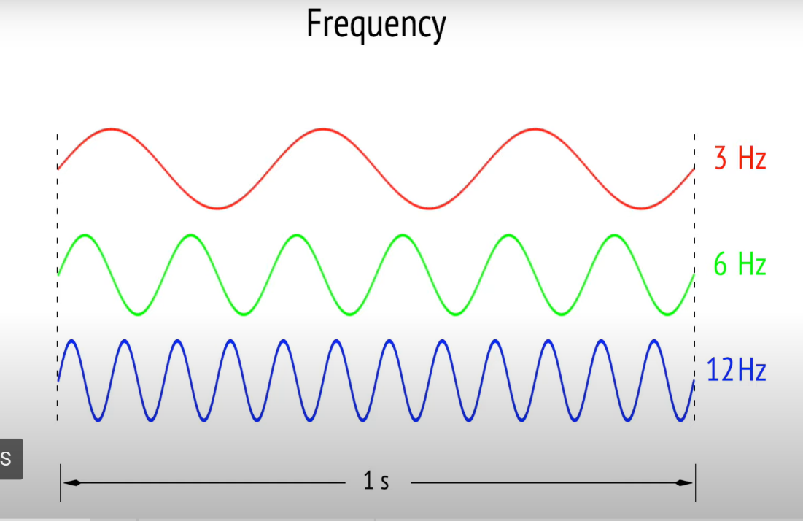

The amount of HZ that happen within 1 second

**Period:**

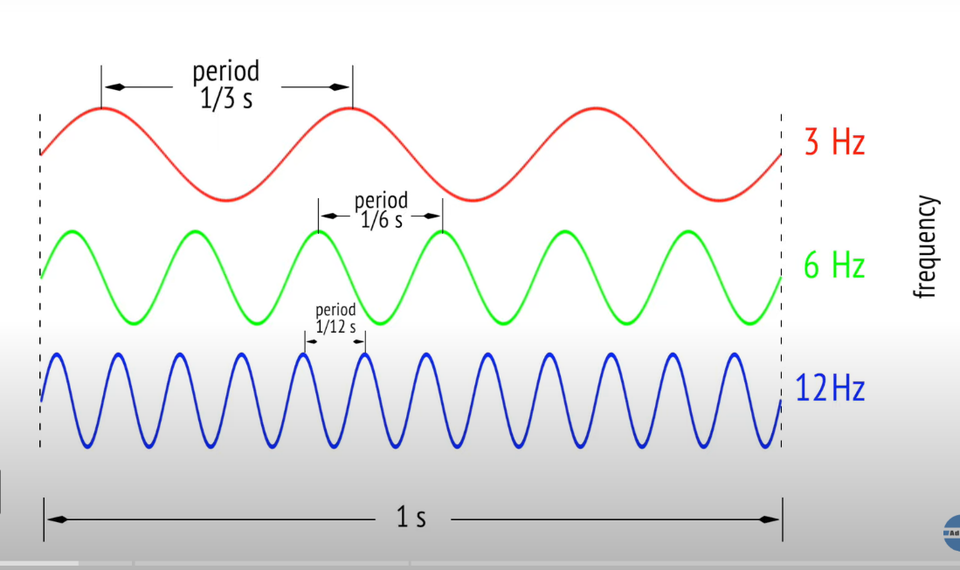

Period is basically the amount of HZ divided by a second, so 3 HZ, each period is 1/3 second if it is uniform.

**Amplitude:**

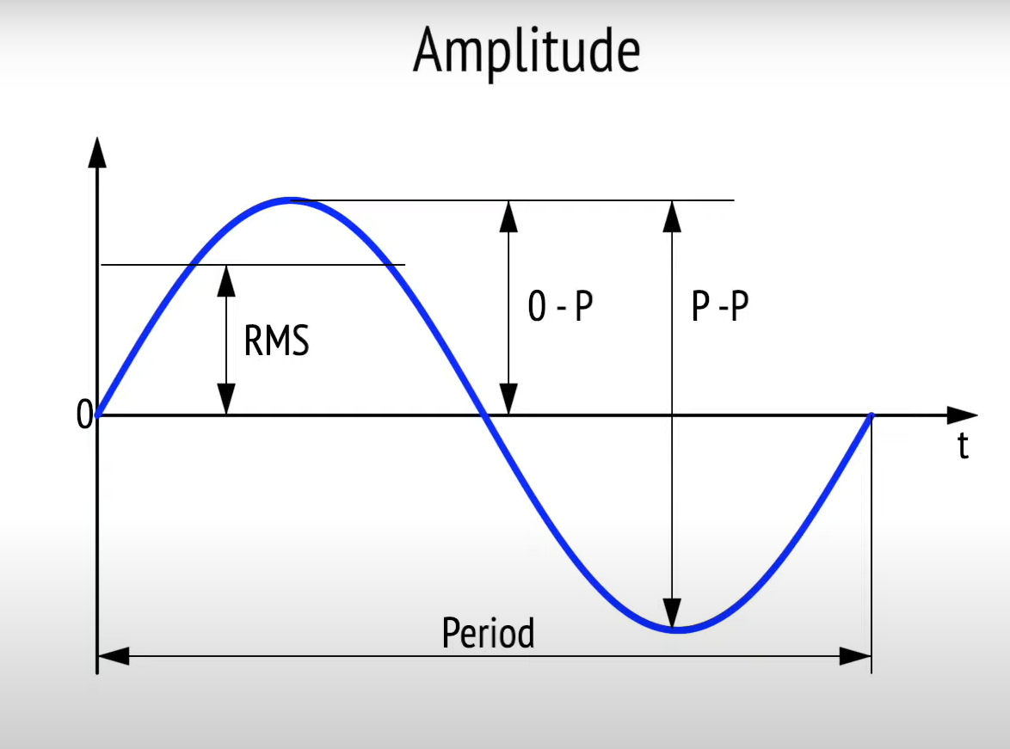

RMS Value:

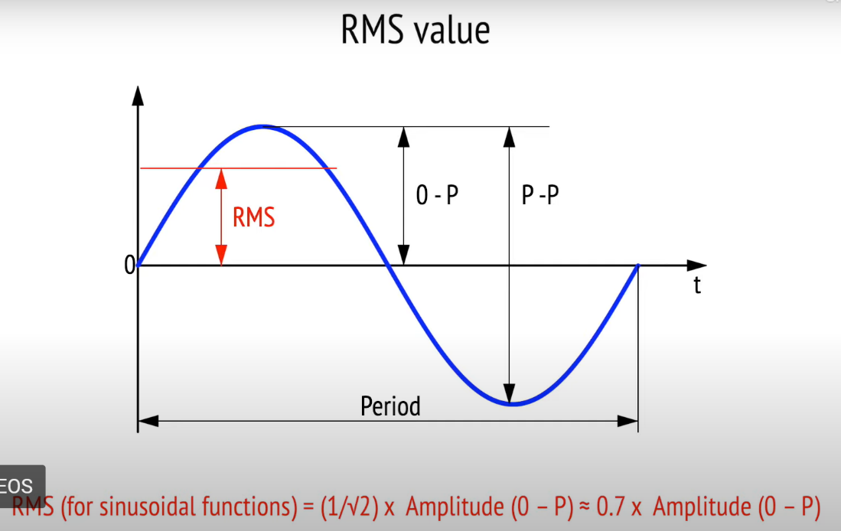

Amplitude can be measured in three different ways:

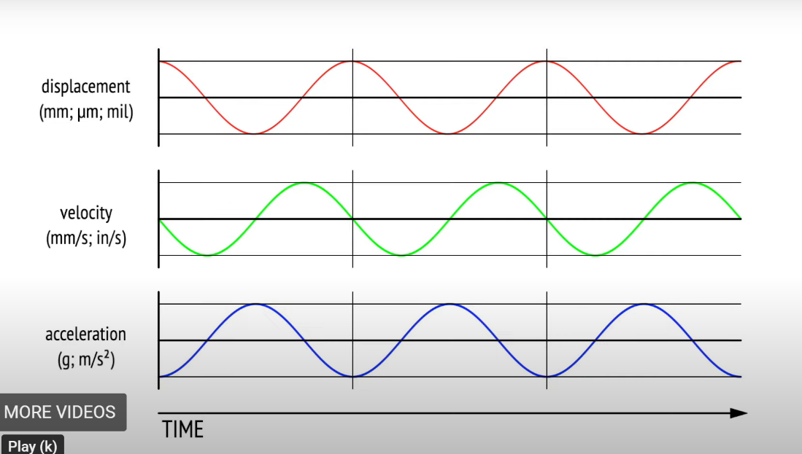

Displacement: How far the measured point is moving.

Units that are used, millimeters, micrometers, or mils

Velocity: Rate of change of distance with respect to time and displacement.

Acceleration: How fast the measured point is changing. G and m/s^2

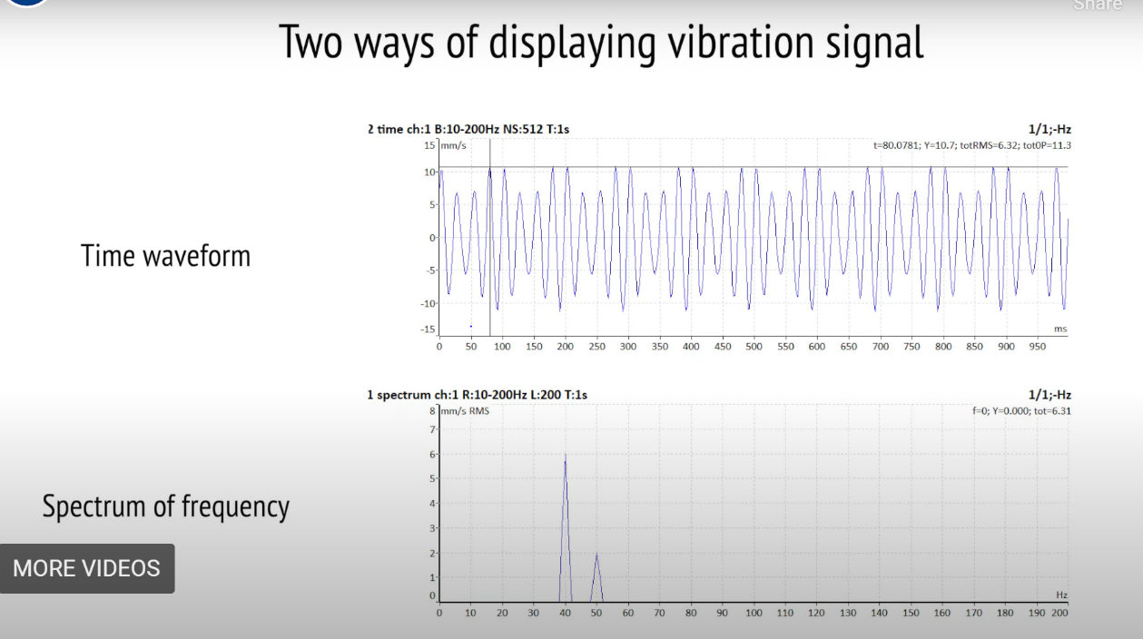

Time waveform is the pure record of change over time.

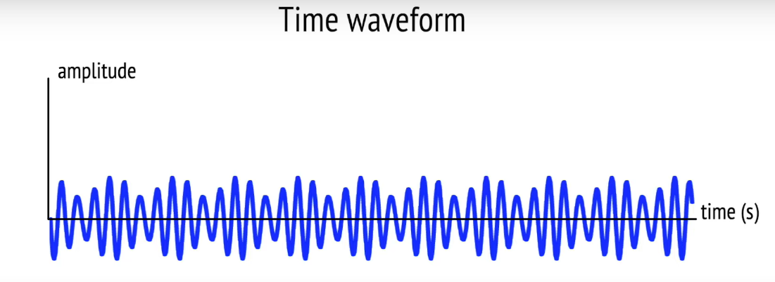

Another type is the spectrum of frequency format

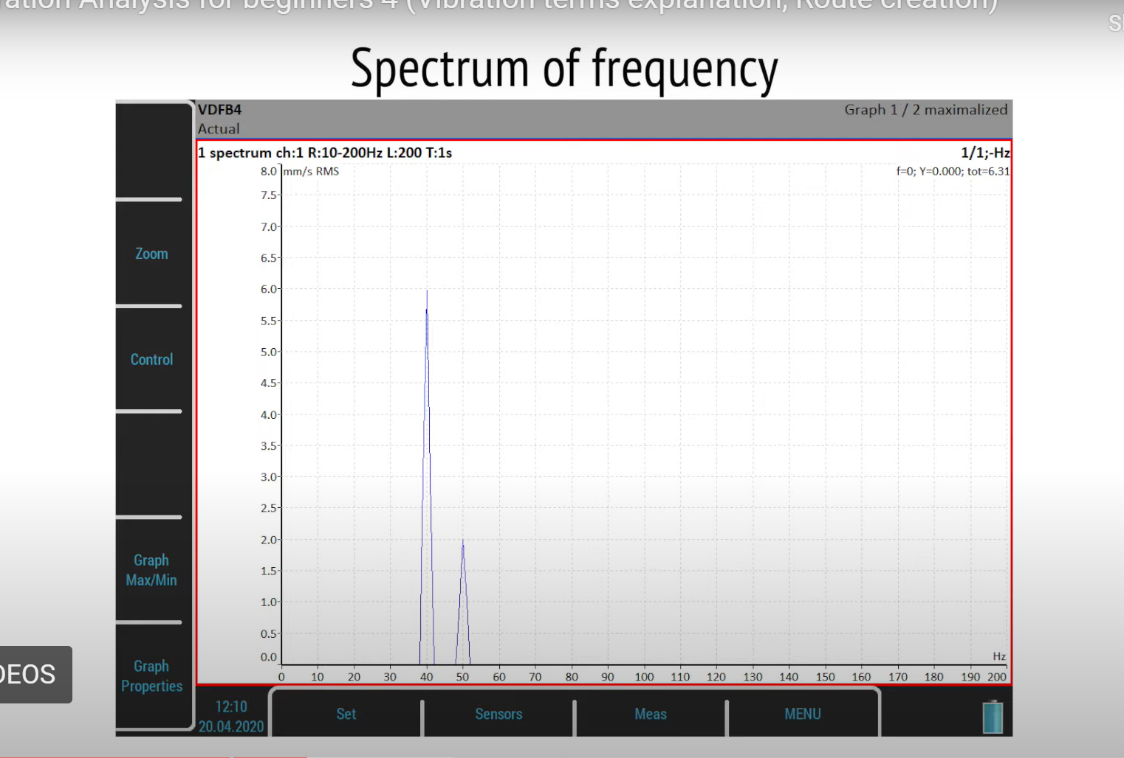

4 minutes into video.

[Vibration Analysis for beginners 4 (Vibration terms explanation, Route creation) - YouTube](https://www.youtube.com/watch?v=qcHjDLCJxfI)

[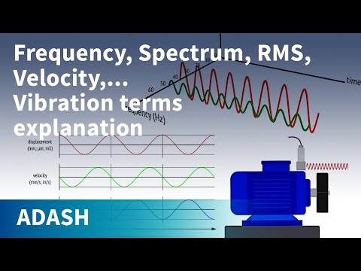](https://www.youtube.com/watch?v=qcHjDLCJxfI)

Advantages of the spectrum view below, sometimes it is difficult to tell which waves are coming from which machine.

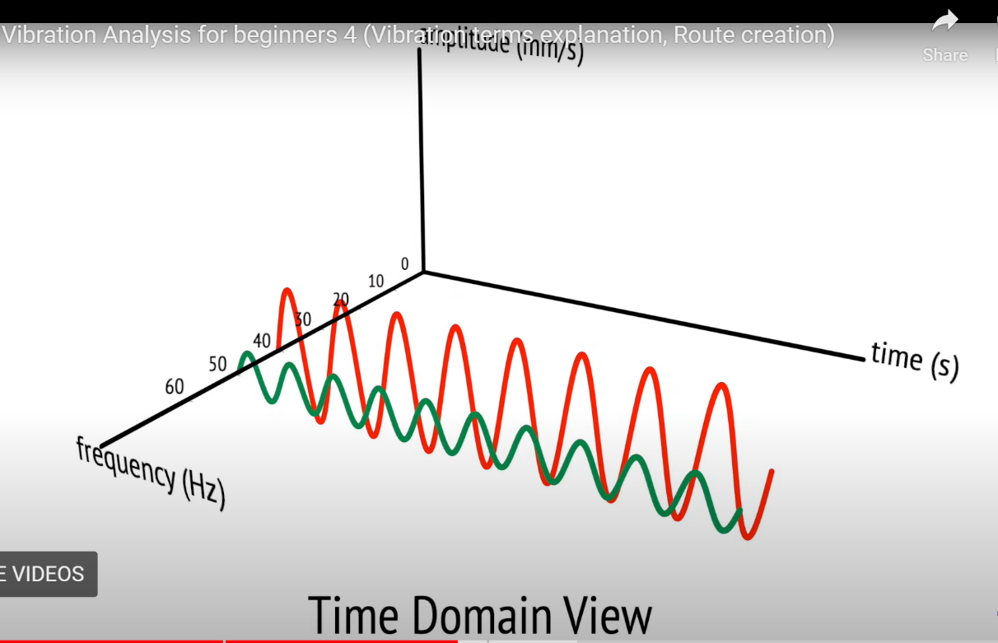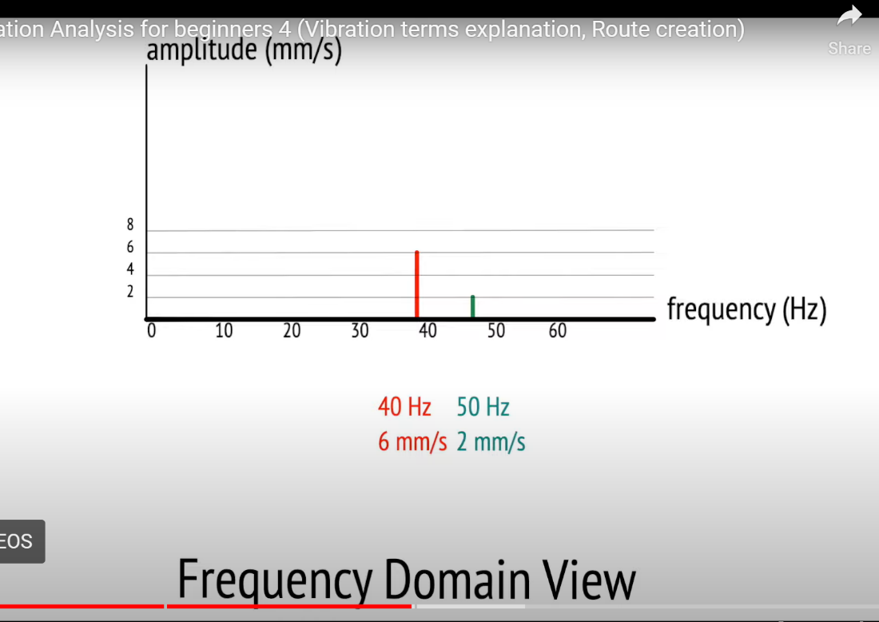

This view is turned around so we can see the difference in both waves, previously they were stacked, and it was different to differentiate.

**What to consider with vibration data:**

1. Predictive Maintenance:

Vibration analysis can identify changes in machine vibration patterns, which often precede mechanical failures. Predictive maintenance models can be developed to anticipate and prevent breakdowns, reducing downtime and maintenance costs.

2. Fault Detection and Diagnosis:

Unusual vibration patterns can indicate specific faults or issues within machines, such as misalignments, unbalanced parts, or bearing defects. Analyzing vibration data helps diagnose these faults accurately. By monitoring vibration levels, you can optimize machine parameters such as speed, load, and alignment to reduce wear and tear. This optimization leads to increased efficiency and longer machine lifespan. Vibration patterns provide information about the condition of bearings and the effectiveness of lubrication systems. Abnormal vibrations can indicate bearing wear or insufficient lubrication, allowing for timely maintenance. Detect resonant frequencies within machines that can lead to excessive vibrations. Adjusting operating conditions to avoid resonance can prevent structural damage and improve overall equipment performance.

3. Quality Control:

Vibration data can reveal variations in product quality caused by machine vibrations. Monitoring and controlling vibrations can help maintain consistent product quality, especially in precision manufacturing processes.

4. Safety Monitoring:

Monitoring excessive vibrations ensures the safety of equipment and personnel. Sudden changes in vibration patterns can indicate dangerous conditions, prompting immediate shutdowns or inspections.

5. Energy Efficiency:

Vibrations can indicate inefficient operations leading to energy wastage. By optimizing machine parameters based on vibration data, energy consumption can be reduced, contributing to cost savings and environmental sustainability.

**How to measure heat:**

Temperature and humidity

Are our temperature sensors converting temperature to an electrical signal as below?

Common ranges from milliamps to volts

More accurate heat the more wires for the transmitters.

This takes the heat in as a current and then sends the current back through to measure the heat. If too much heat/current comes through it may not work as expected.

How measure resistance in ohms for our RTD.

Temperature range for 1 wire configs -330 to 1560

RTD vs Thermocouple

Thermocouples are self-powered while RTD require an external source

Thermocouples are slightly less accurate, they also need a thermo reference point from the cold junction.

Types of thermocouples and how to calculate:

**Semiconductor:**

Least accurate but easier to calculate and use.

**Overall:**

**What can we consider with thermal data:**

1. Real-Time Monitoring:

Implement real-time monitoring systems to keep track of heat levels and other sensor data during production. Visualize this data on dashboards to quickly identify any anomalies or deviations from the norm.

2. Predictive Maintenance:

Analyze historical sensor data to identify patterns and correlations between heat levels and machine failures. Implement predictive maintenance models that can predict when equipment might fail based on changes in heat patterns. By anticipating failures, you can schedule maintenance activities before they disrupt production. Integrate sensor data with other relevant data sources, such as production schedules, maintenance logs, and inventory levels. Comprehensive analysis of integrated data can provide a holistic view of the production process and help in making more informed decisions.

3. Process Optimization:

Use sensor data to optimize the production process. Analyze how variations in heat levels affect the quality of the product. Adjust machine settings based on this data to ensure consistent product quality while minimizing energy consumption and production time.

4. Energy Efficiency:

Monitor heat levels alongside energy consumption data. Identify opportunities to optimize energy usage by correlating heat levels with energy efficiency. Adjust machine operations to maintain optimal heat levels while reducing energy consumption.

5. Quality Control:

Utilize sensor data to establish quality control measures. Correlate heat levels with product quality metrics. Implement automated checks and alerts based on sensor data to ensure that products meet quality standards.

6. Skewness:

Measures the asymmetry of the sensor data distribution. Positive skewness indicates a longer tail on the right side of the distribution, while negative skewness indicates a longer tail on the left side.

7. Kurtosis:

Describes the tailedness of the data distribution. High kurtosis indicates heavy tails and more outliers, while low kurtosis indicates light tails.

8. Energy Consumption:

Calculated based on sensor data to assess the energy used during specific machine operations.

9. Duty Cycle:

Represents the fraction of time the machine operates compared to the total available time. Useful for understanding machine utilization.

**Appendix:**

Number 1 (Madgwick Filter):

For converting gyroscope data to quaternion representation, you can use sensor fusion algorithms that typically involve quaternion integration. Two commonly used algorithms for this purpose are the Madgwick filter and the Mahony filter.

Let's denote the gyroscope measurements as ωx , ωy , and ωz for the X, Y, and Z axes, respectively. The quaternion is represented as q=[q0, q1, q2, q3]q=[q0 ,q1 ,q2 ,q3 ].

The Madgwick filter update formula is as follows:



Here:

q⊗ denotes quaternion multiplication.

Δt is the time step between measurements.

In this context, q0 is the scalar part of the quaternion, and q1 , q2 , q3 are the vector part. The resulting quaternion represents the orientation of the sensor.

Number 2:

acceleration a(t) over time, denoted as a0 ,a1 ,a2 ,…, with a constant time step Δt, the velocity

v(t) and displacement s(t) can be estimated as follows:

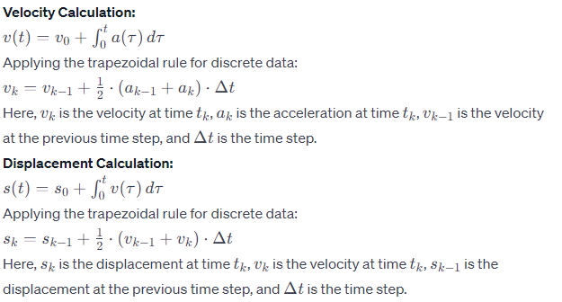

Number 4:

* Obtain Accelerometer and Magnetometer Data:

Read the accelerometer data (ax ,ay ,az ) and magnetometer data (mx ,my ,mz ) from the sensor.

* Normalize Accelerometer Data:

Normalize the accelerometer vector to obtain the gravity vector (gx ,gy ,gz ) by dividing each component by the magnitude of the accelerometer vector: gravity vector=gravity vector=ax2 +ay2 +az2 (ax ,ay ,az )

* Calculate Tilt Angles:

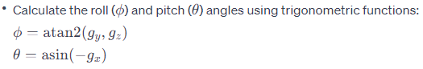

* Normalize Magnetometer Data:

Normalize the magnetometer vector to obtain the magnetic field vector (bx ,by ,bz ) by dividing each component by the magnitude of the magnetometer vector: magnetic field vector.



* Compensate for Tilt:

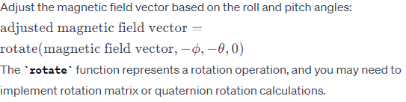

Calculate Magnetic Heading:

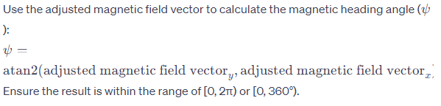

Number 7:

*Collect Accelerometer Data:*

Retrieve accelerometer data from your sensor. This typically includes three-axis acceleration

Calculate Magnitude of Acceleration:

Compute the magnitude of the acceleration vector:

*Define Thresholds:*

Set thresholds for different levels of activity. For example, you might have thresholds for sedentary behavior, light activity, moderate activity, and vigorous activity. These thresholds will depend on the characteristics of your specific application and may require some experimentation.

*Identify Activity Intervals*

*Calculate Energy Expenditure*